Step 1: open a eclipse

Step 2: click on help and go to eclipse market place

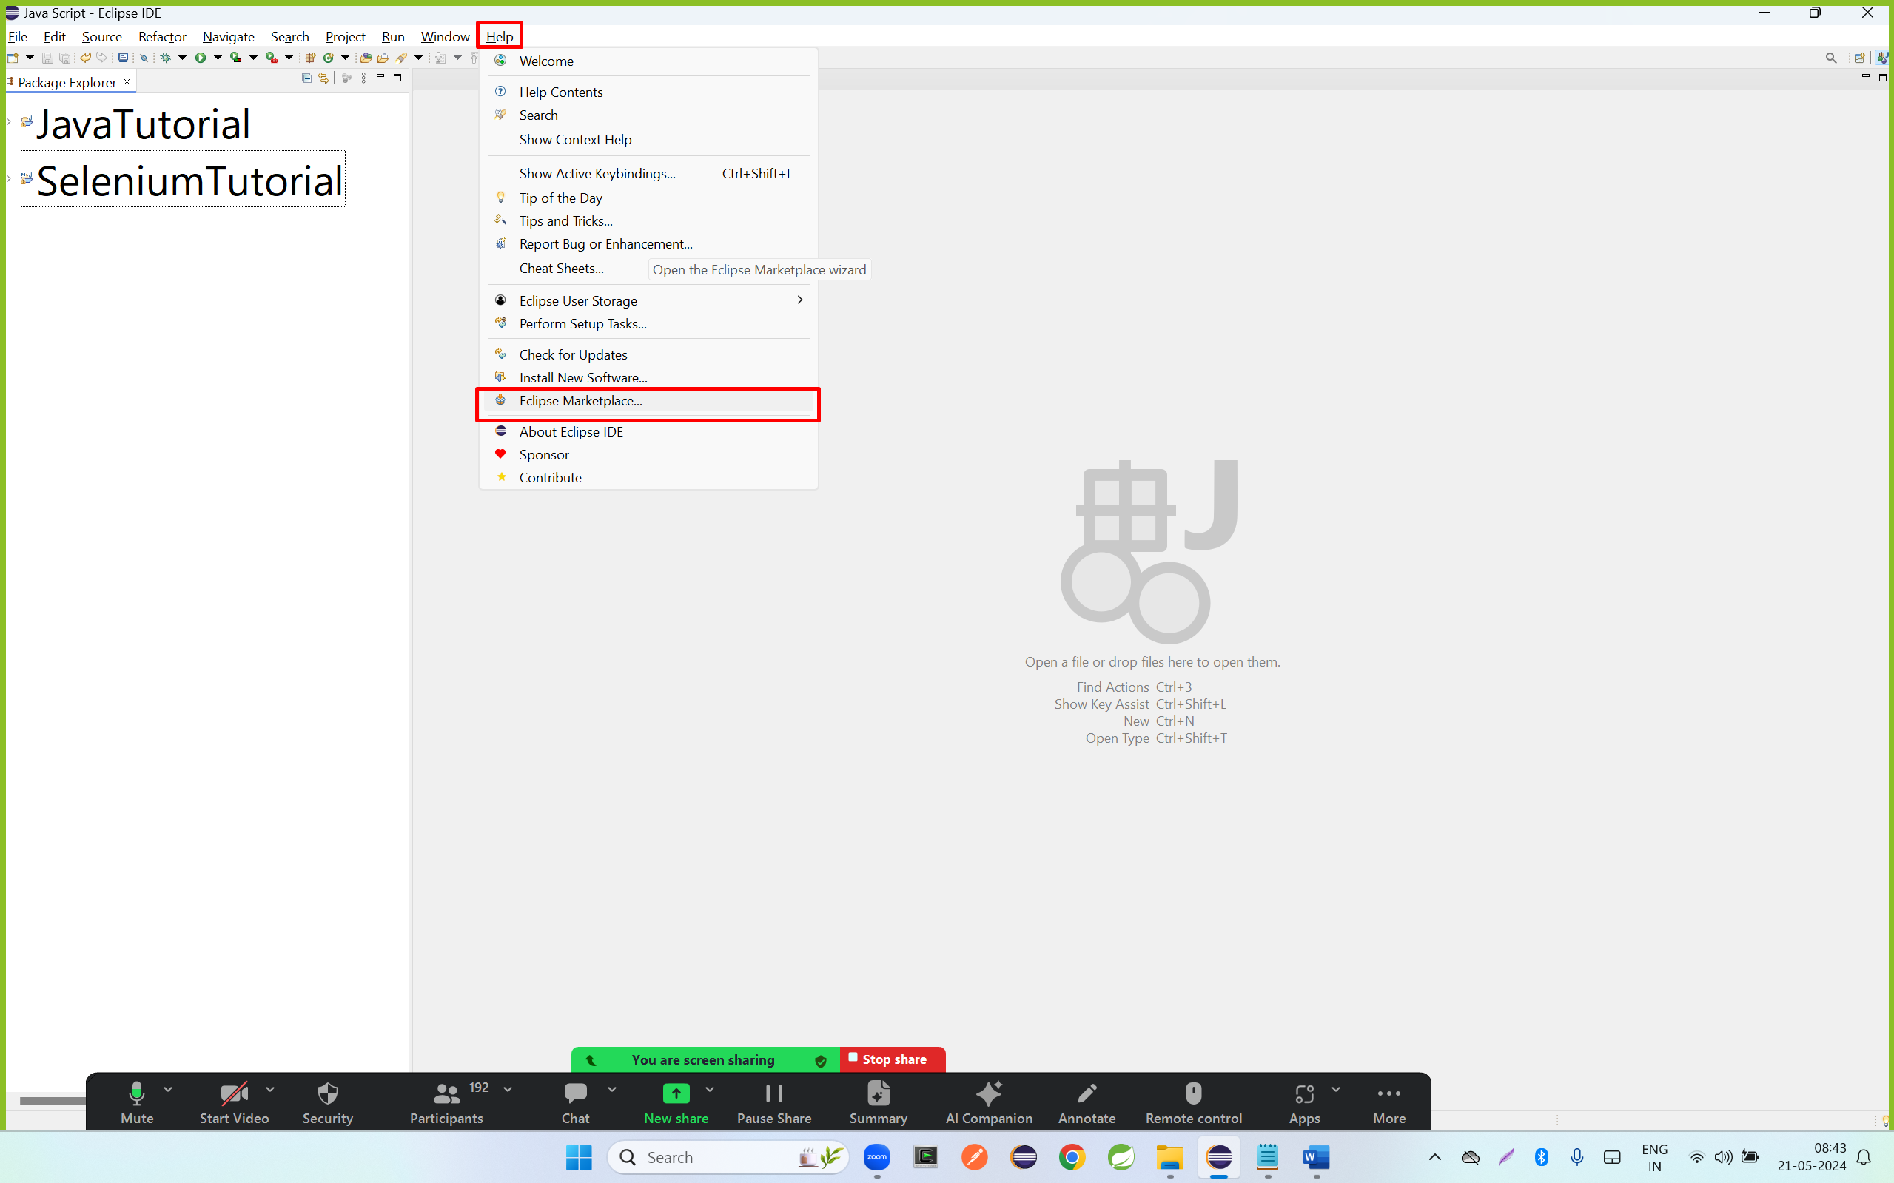

Step 3: search TestNG and click on install button

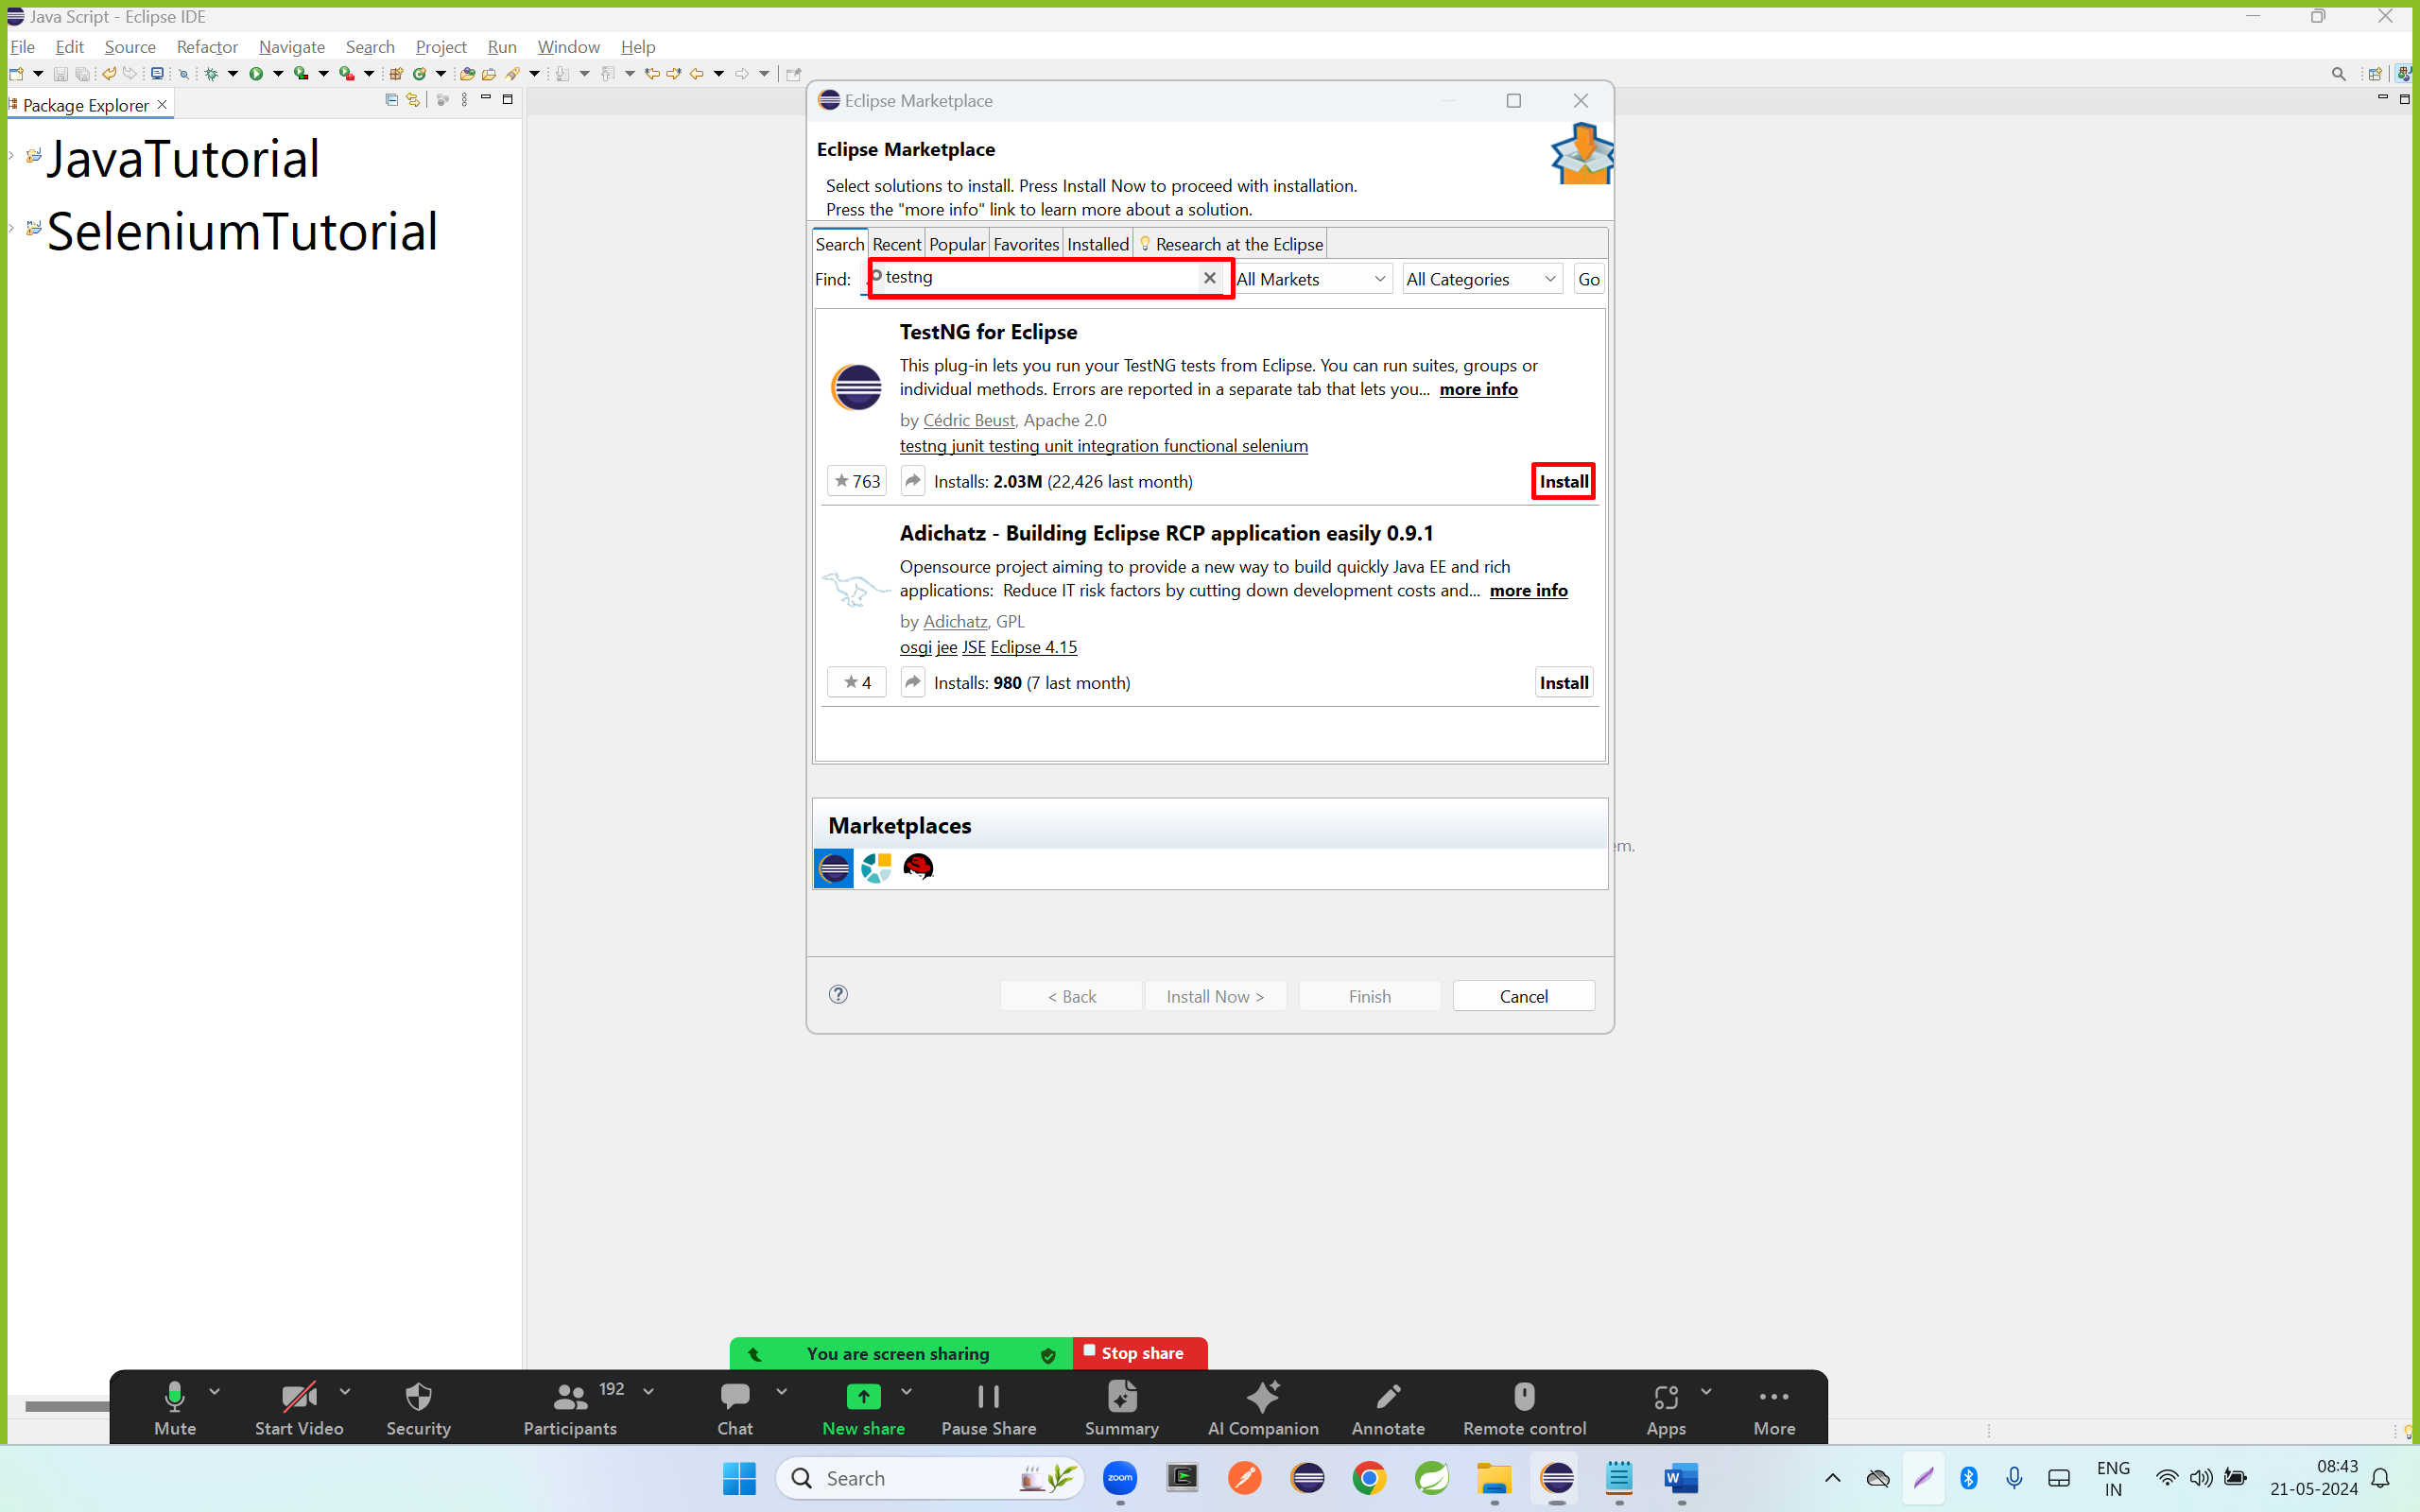

Step 4: select all checkbox and click on confirm button

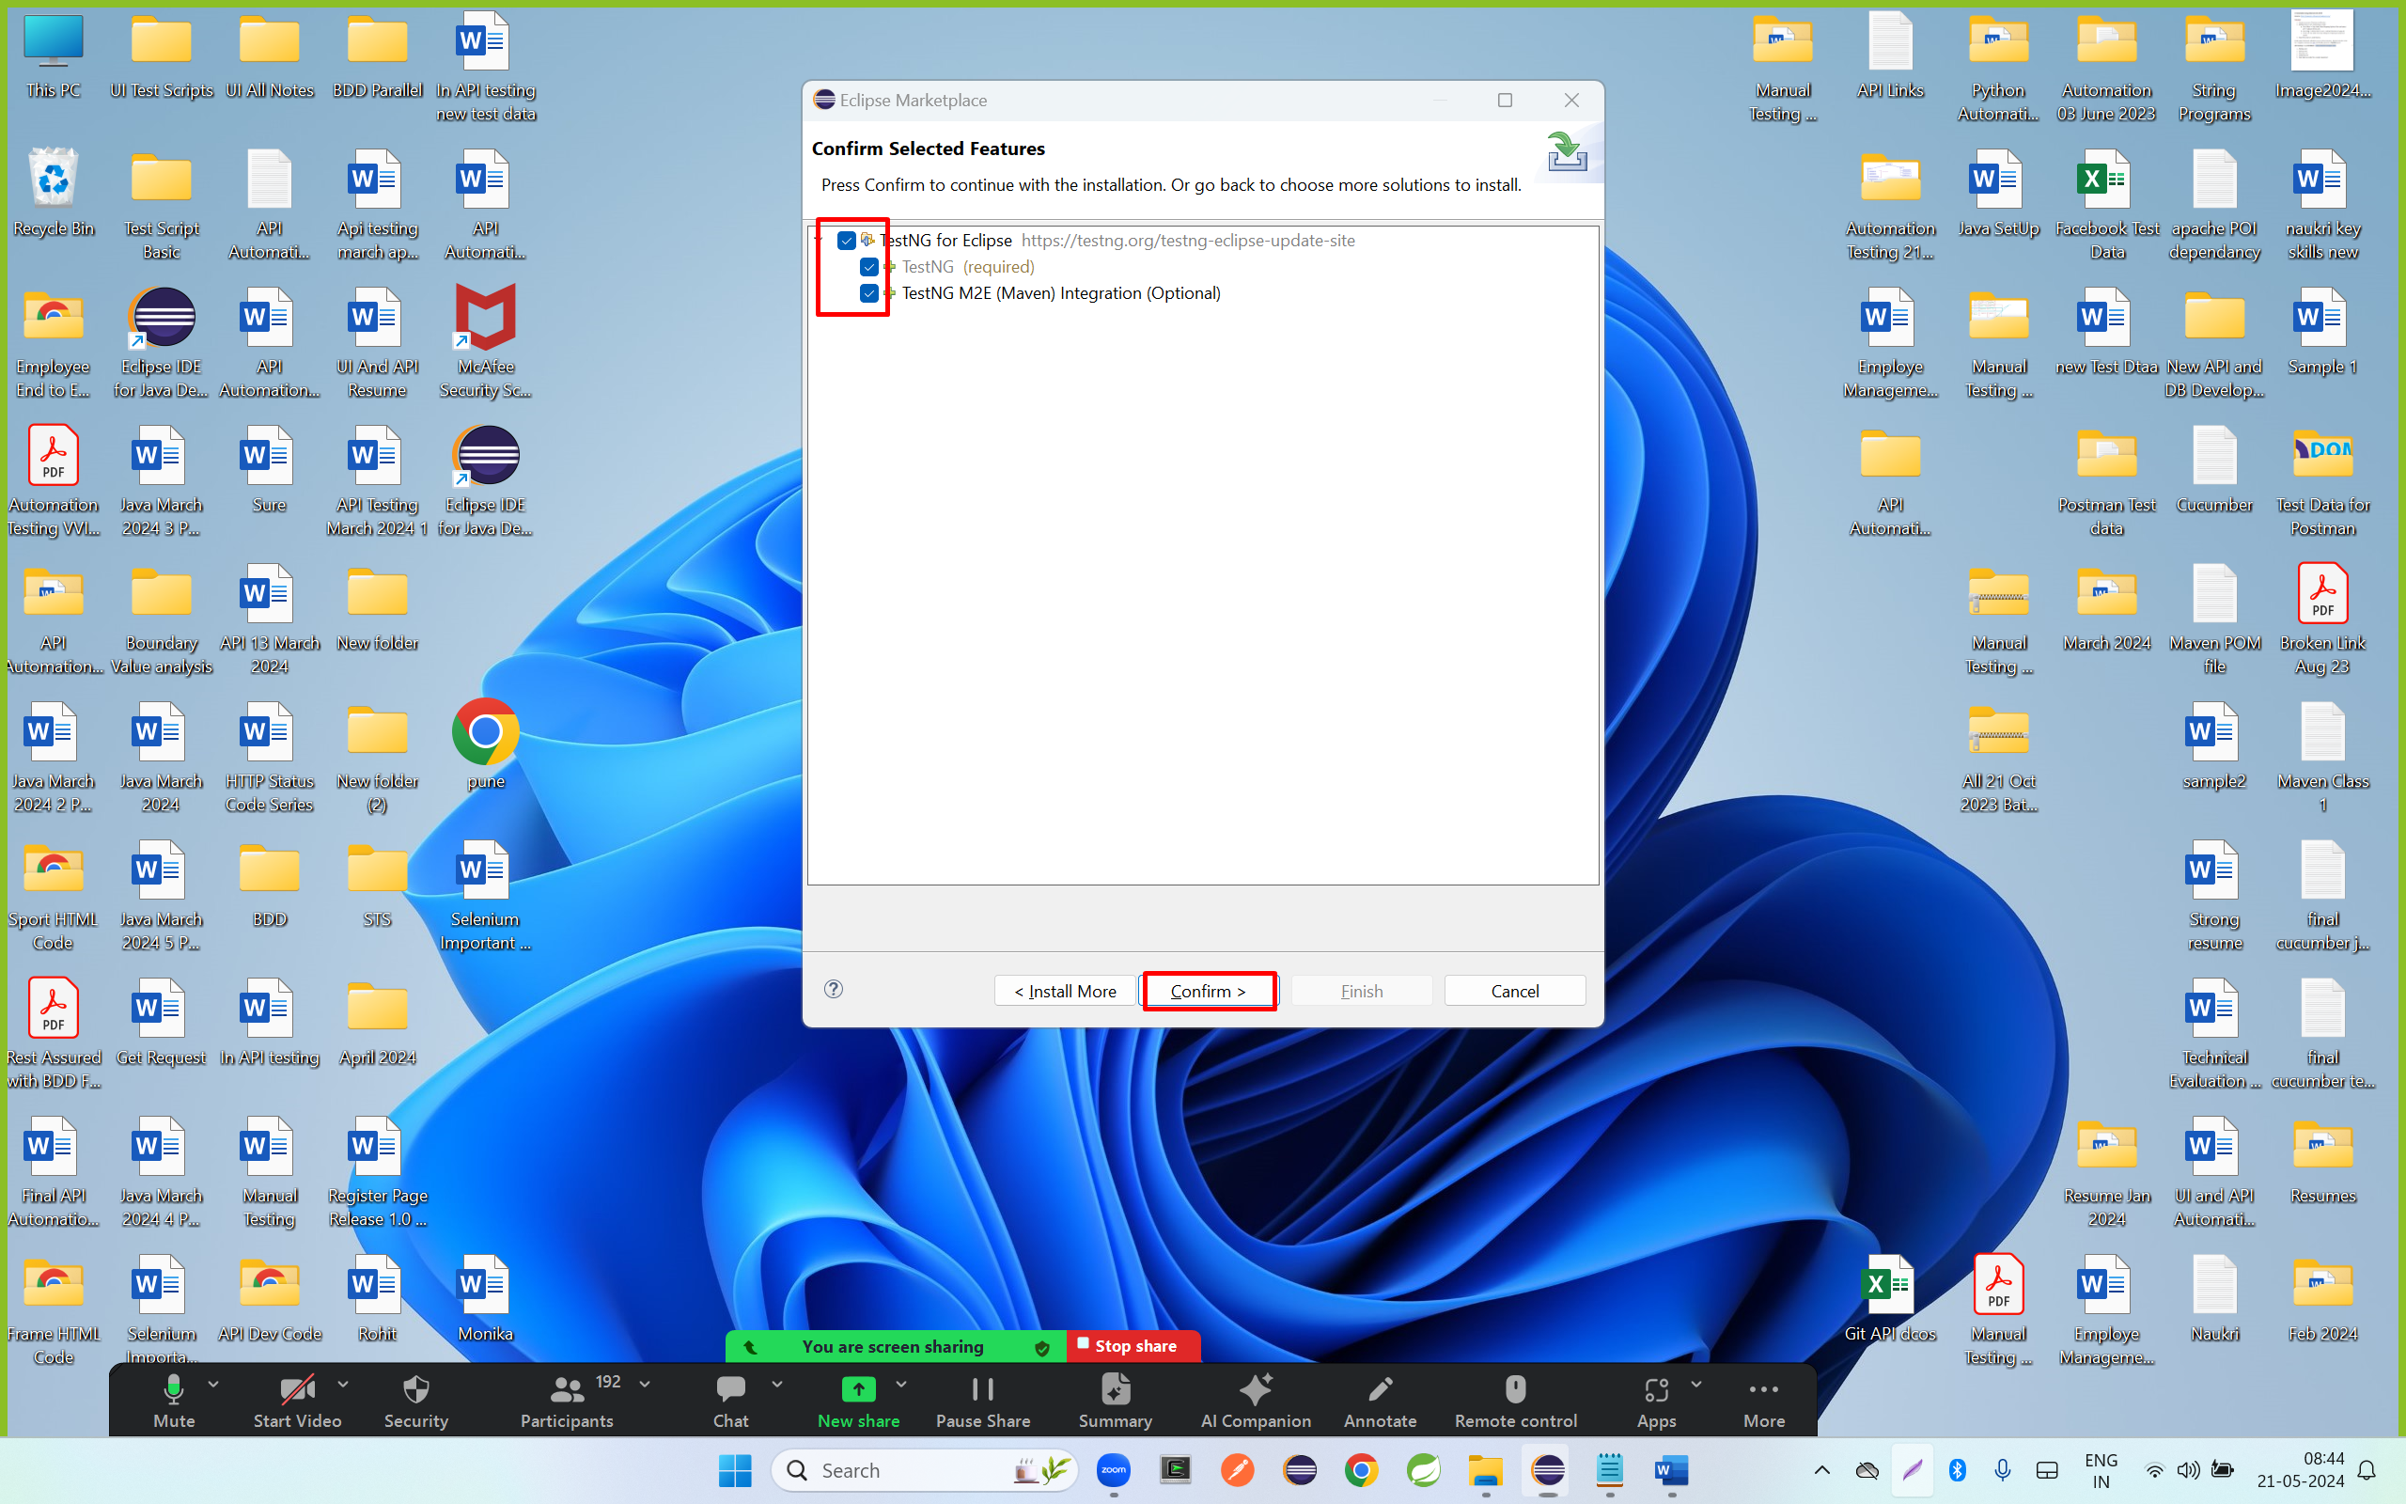

Step 5; select radio button and click on finish

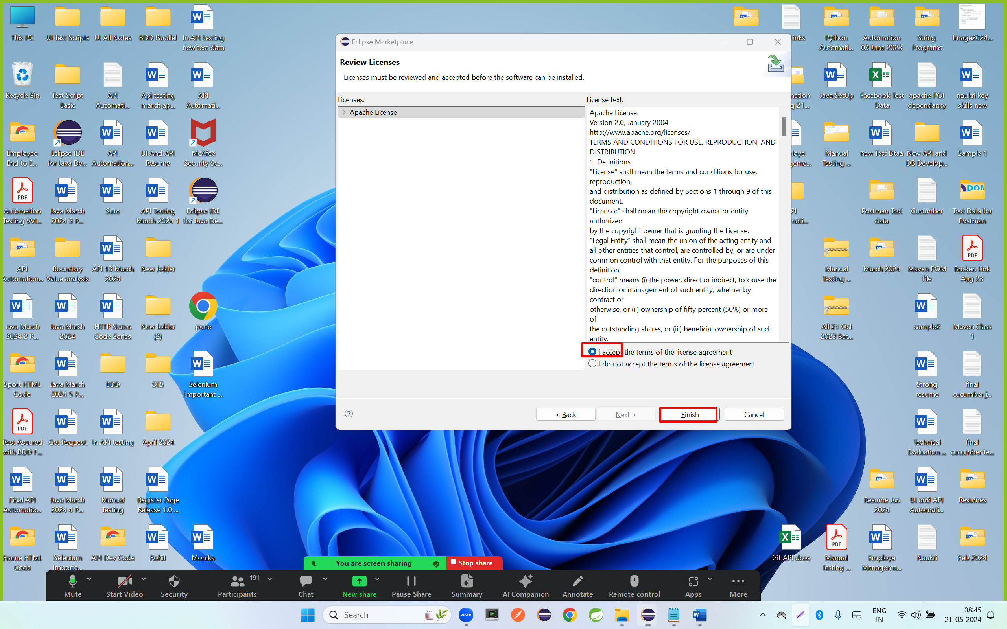

Step

Step 6: click on select all

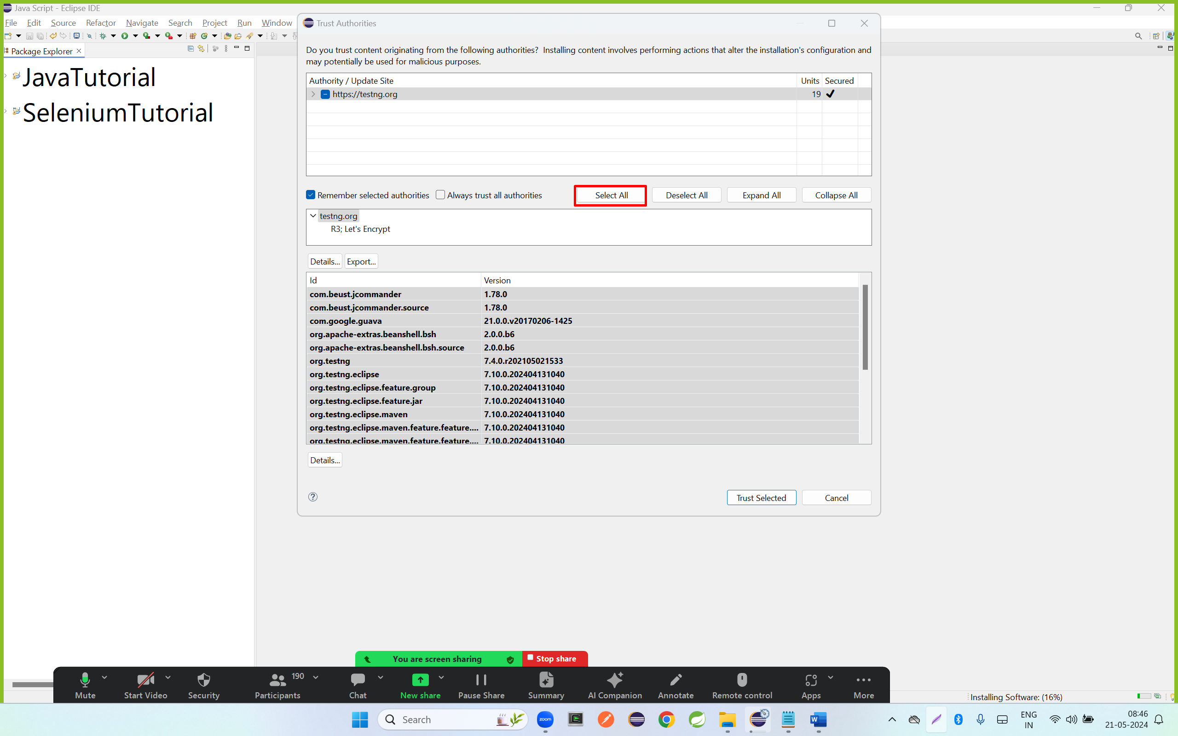

Step 7: click on always trust all

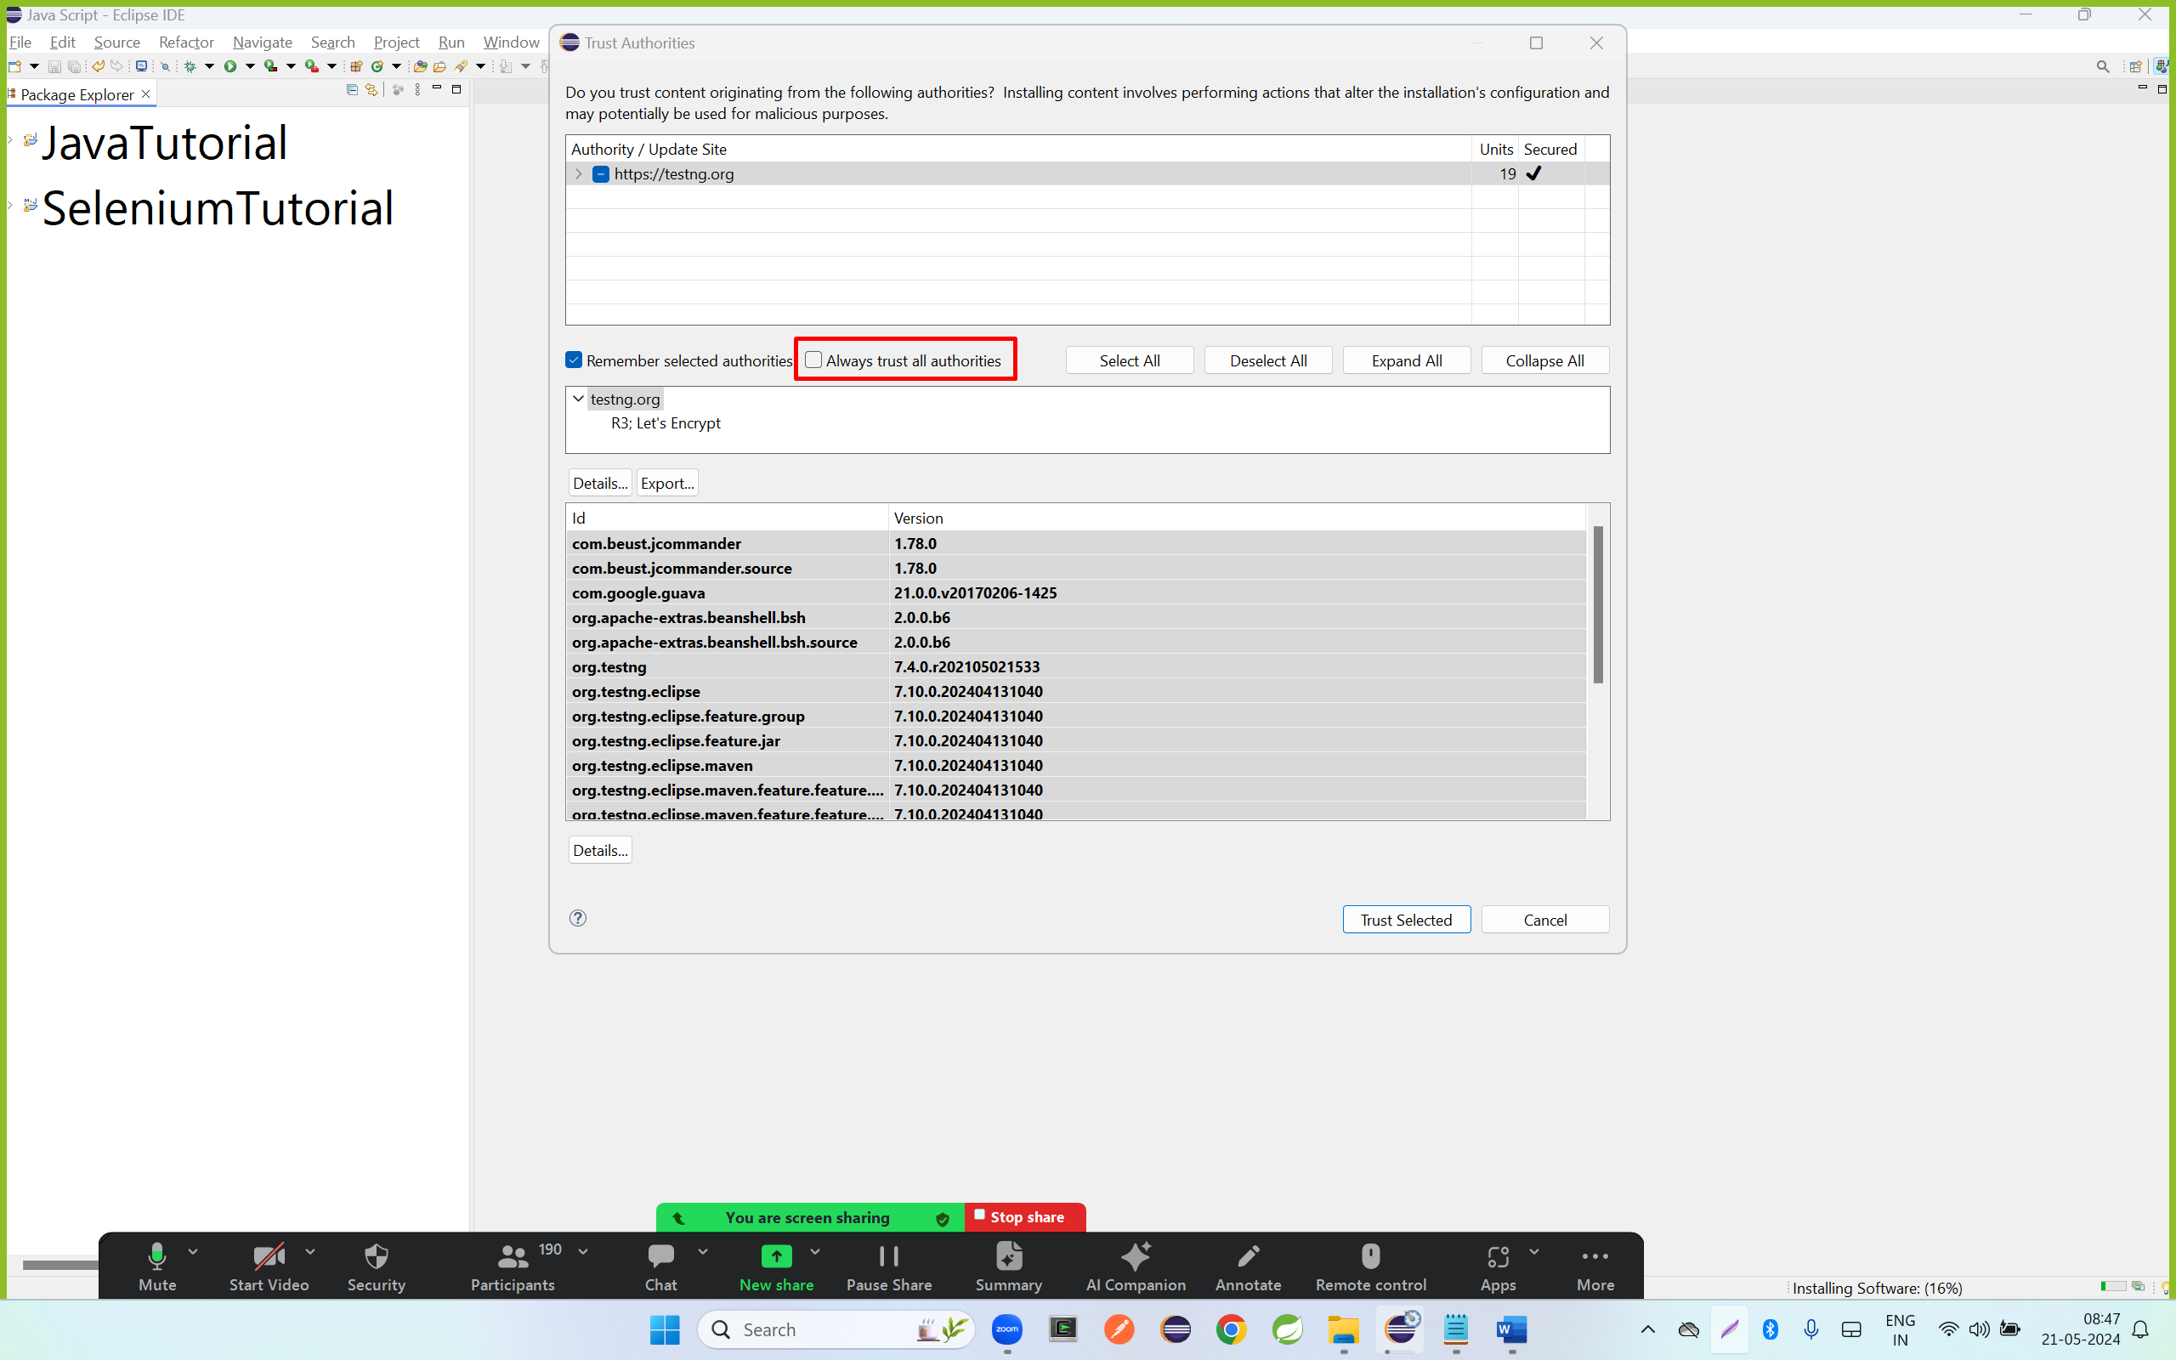

Step 8; click on yes I accept the risk

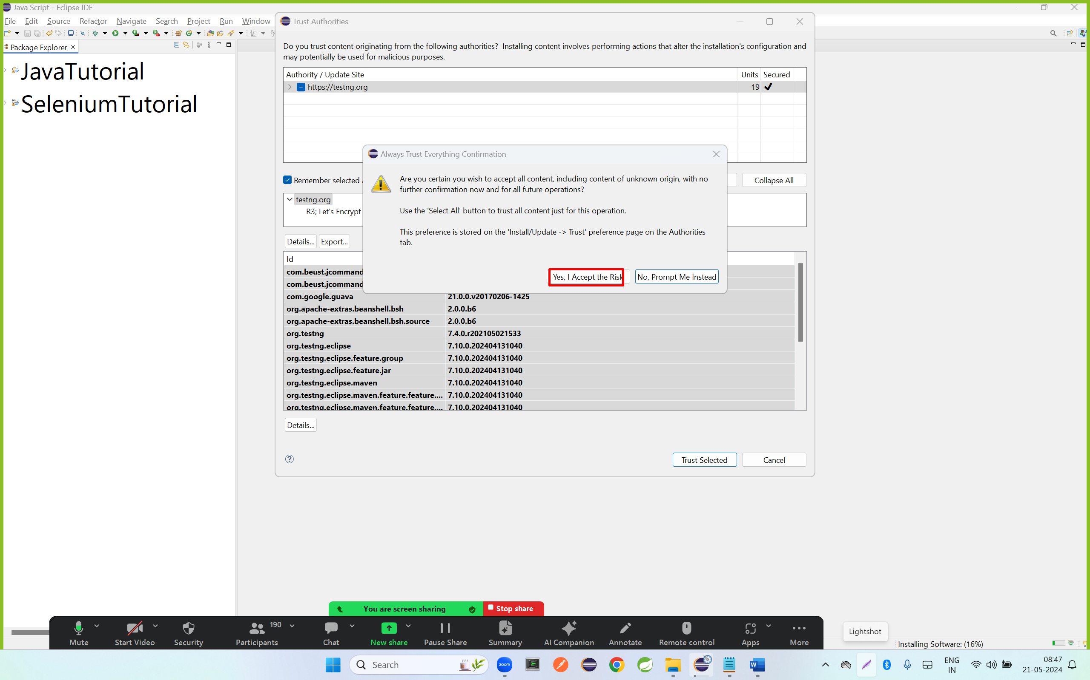

Step 9 : click on trust selected

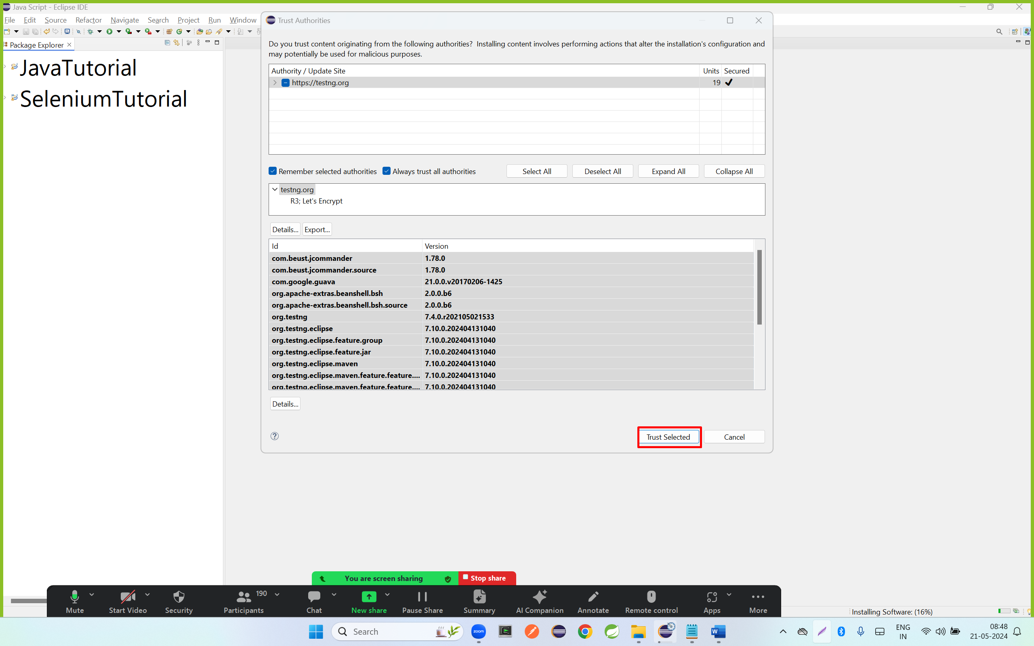

Step 10: click on select all

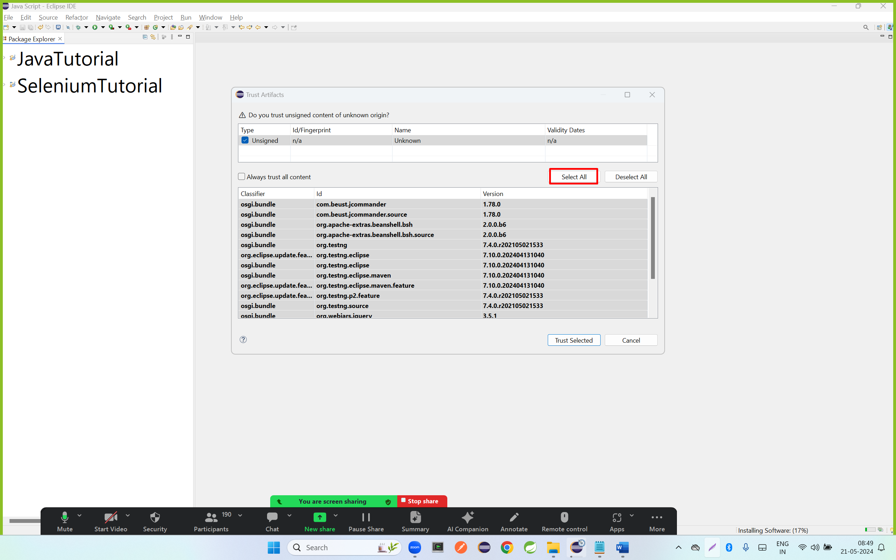

Step11: click on always trust all content

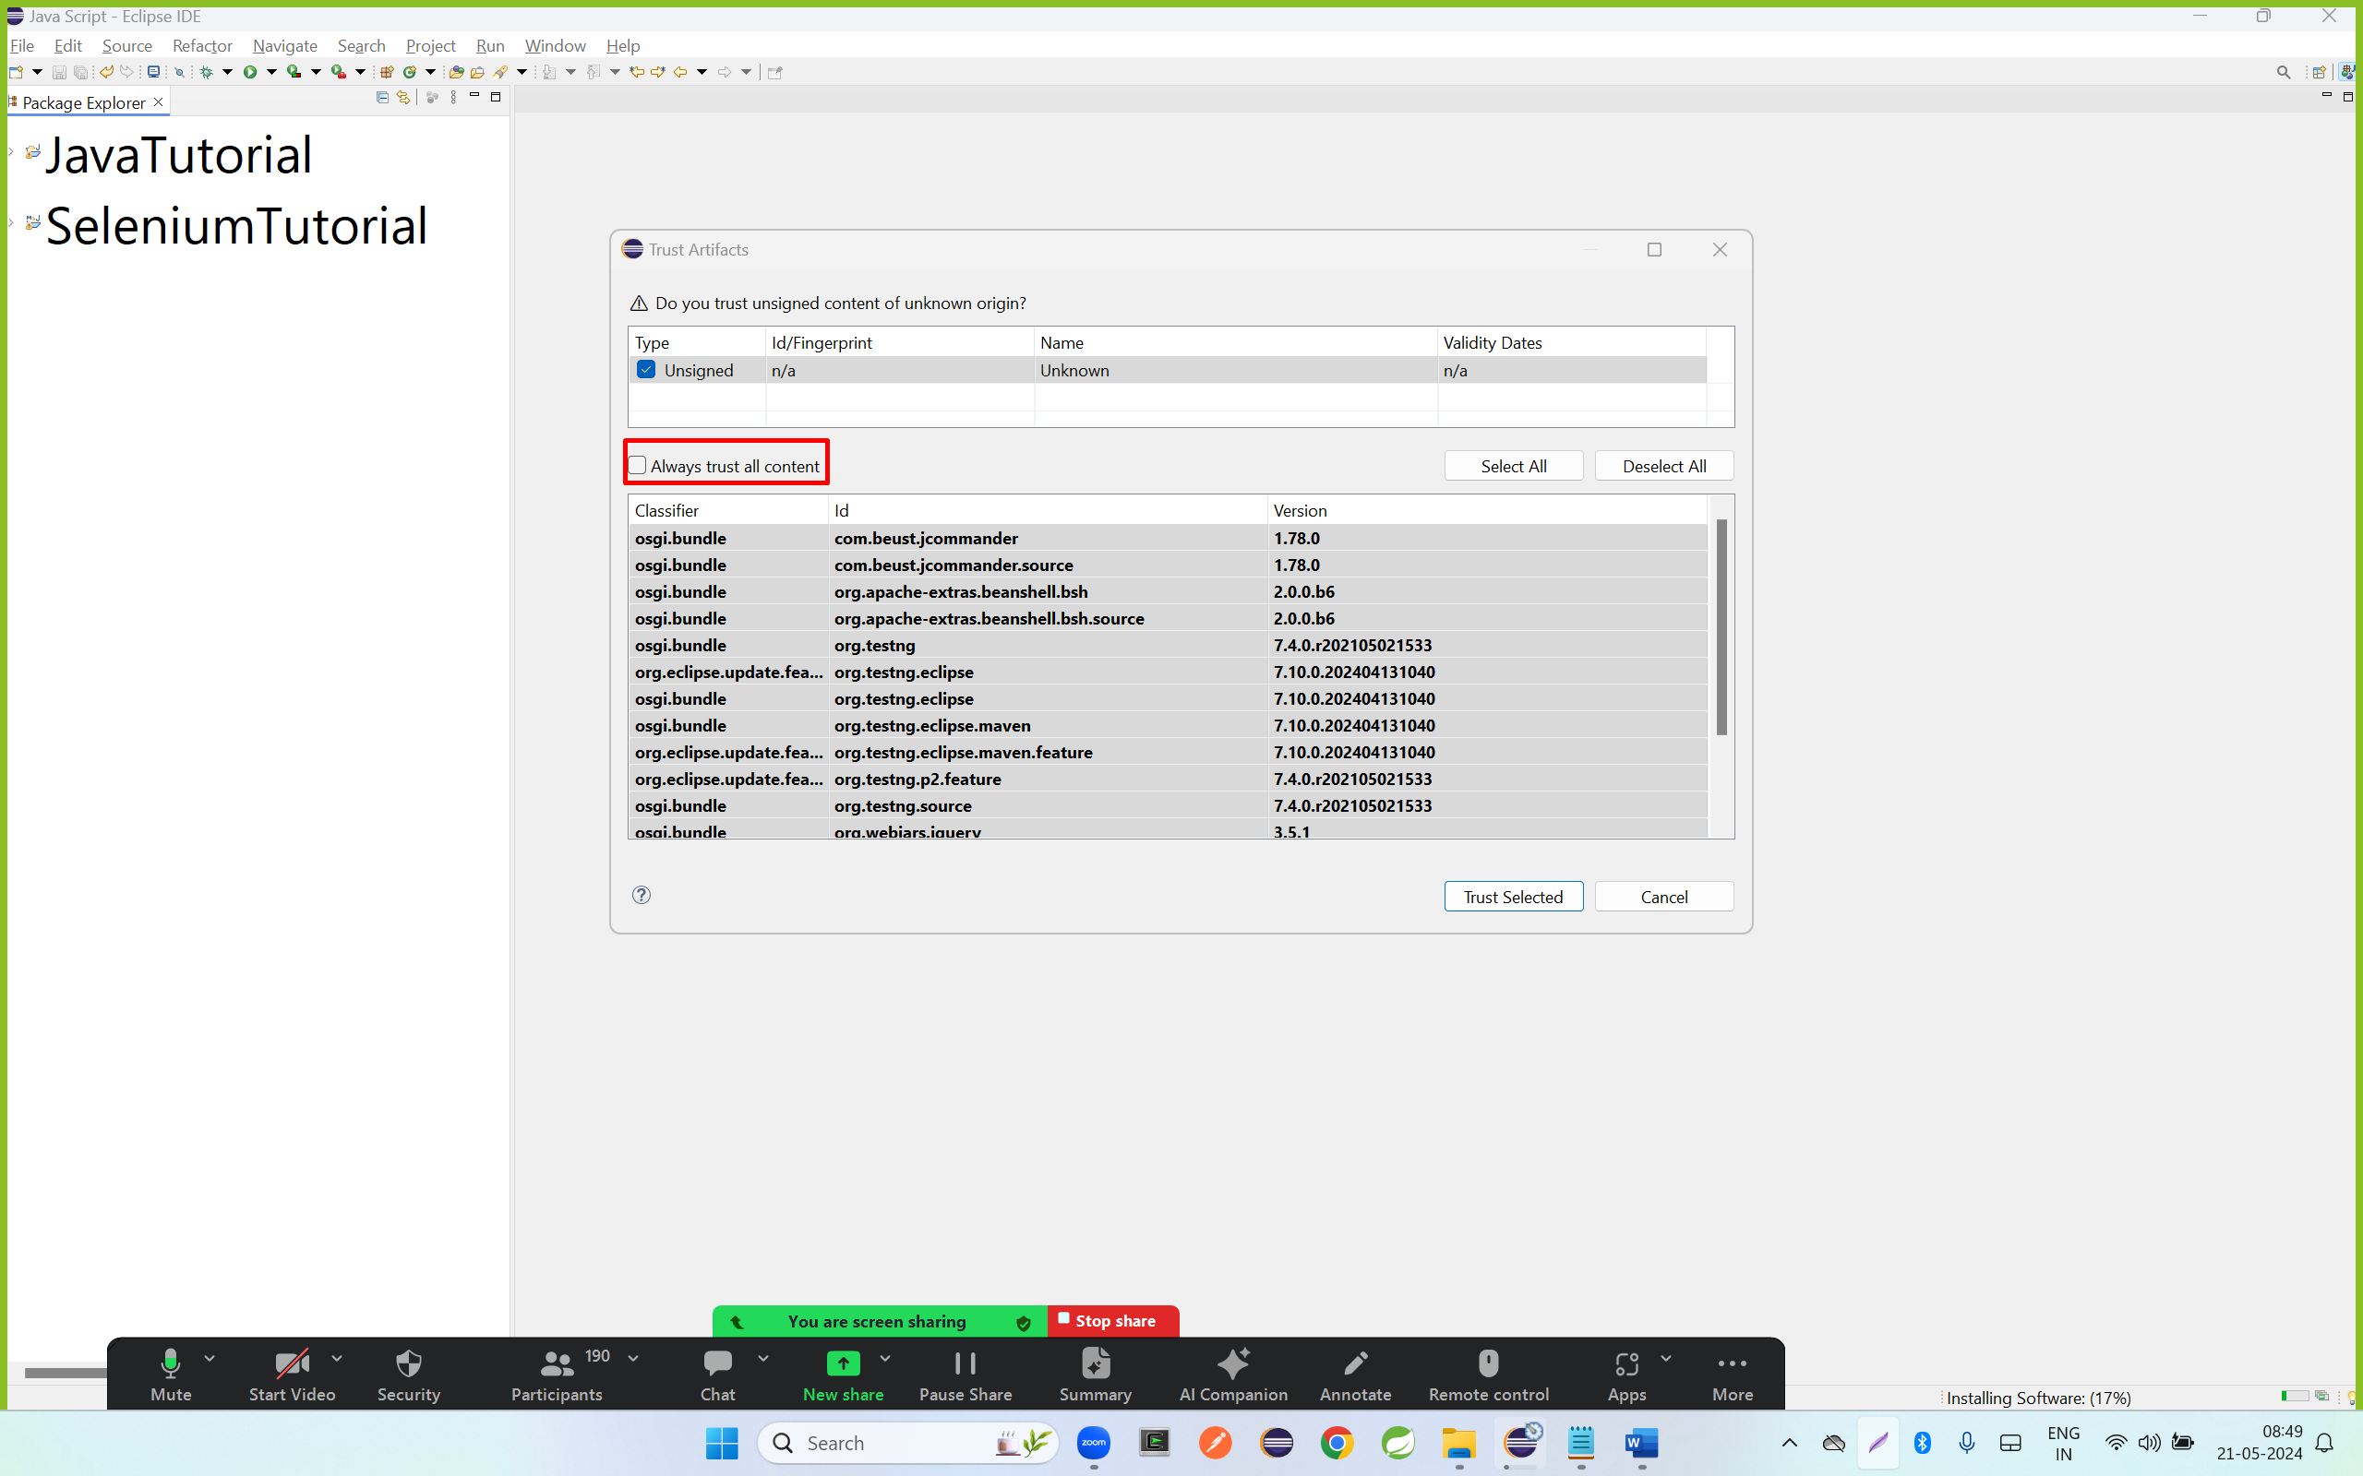

Step 13: click Yes, I accept the risk

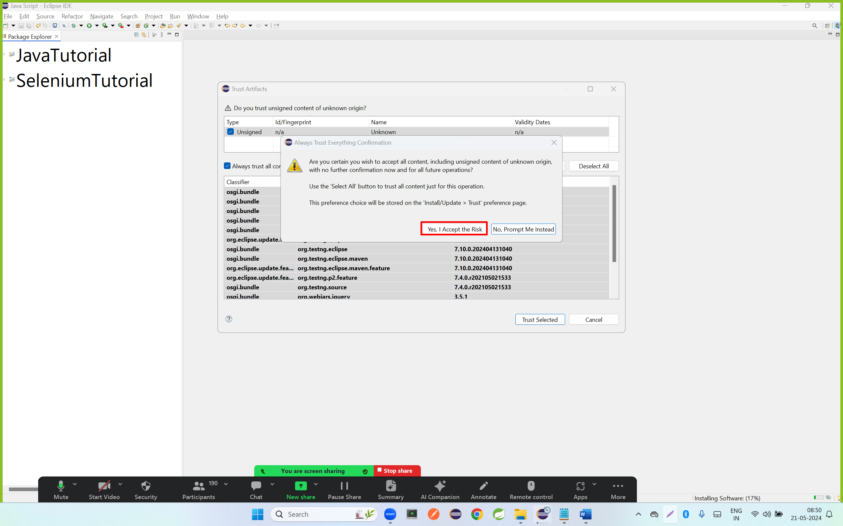

Step 13: click on trust selected

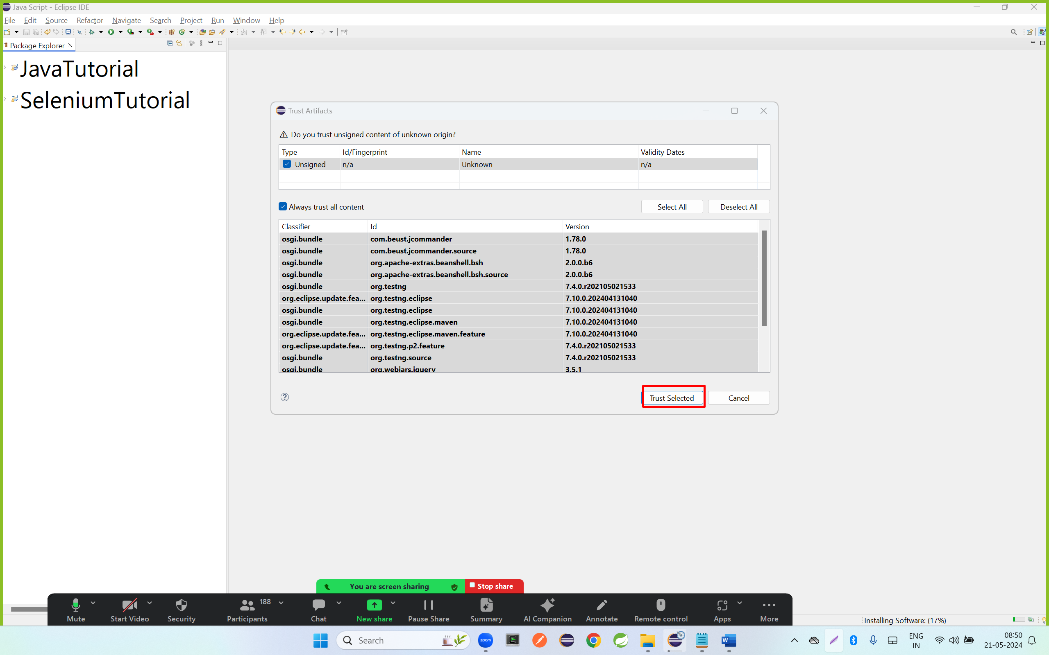

Step 14: verify the Testng is installed or not?

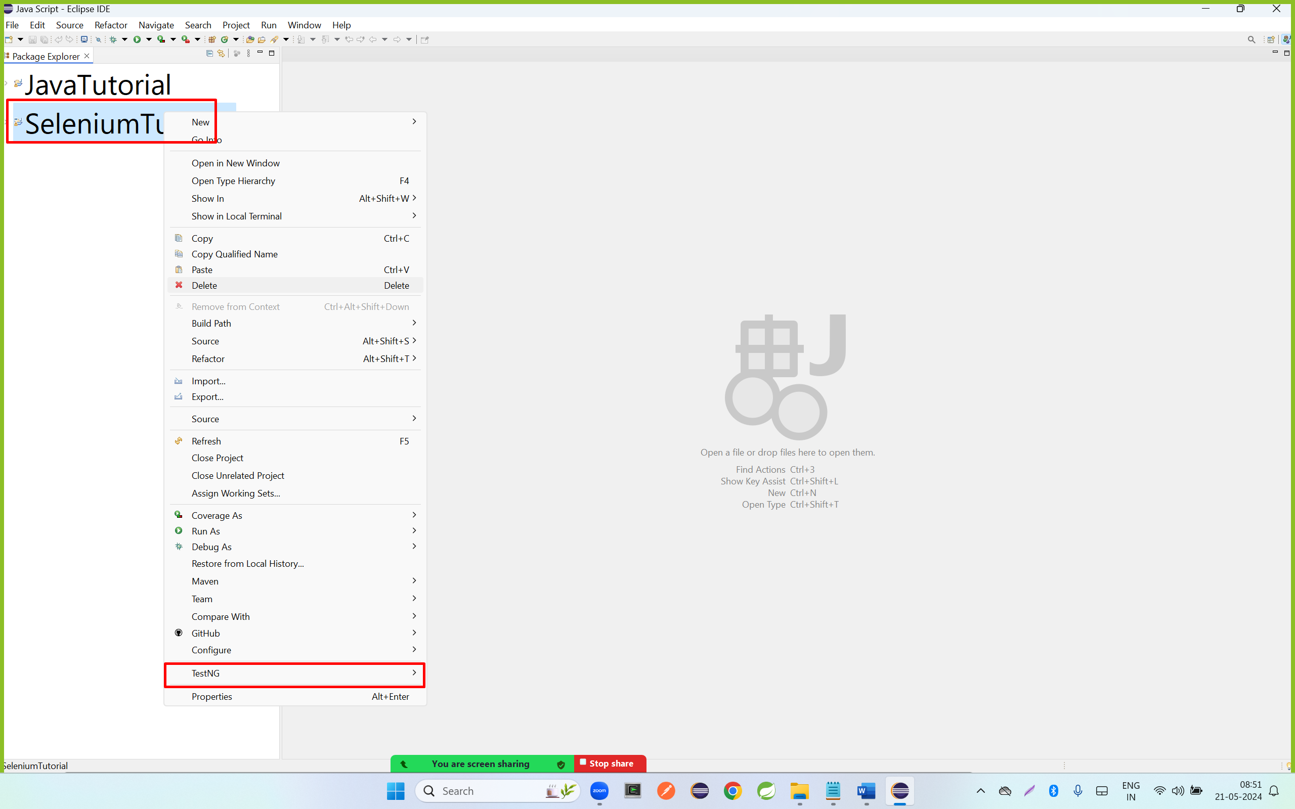

|  |
| --- |
| <!-- https://mvnrepository.com/artifact/org.testng/testng -->  <dependency>  <groupId>org.testng</groupId>  <artifactId>testng</artifactId>  <version>7.4.0</version>  <scope>test</scope>  </dependency> |